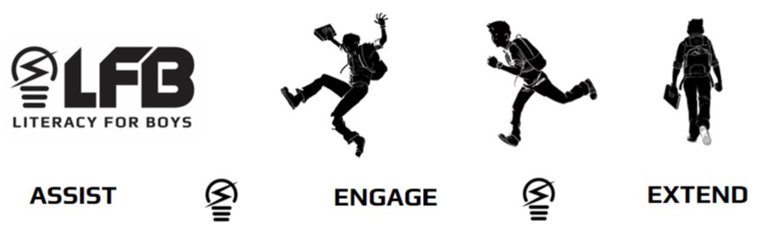
Reluctant Male Readers (11+ years)

Try some of these books for the reluctant reader. You can print this list and take it to the library (or better still order them online from your local library!)

Booth, Coe. Tyrell (Tyrell’s life in the South Bronx is less than perfect as he struggles to keep his little brother safe while trying to raise money doing something other than selling drugs)
Butcher, A. J. Spy High series (The six members of Bond Team are students at Spy High, a training school for the best secret agents, but before they can save the world they have to leanr to work together.)
Colfer, Eoin. Artemis Fowl series (Artemis Fowl is a genius with unlimited wealth and no conscience to speak of, but his kidnapping of fairy Captain Holly Short sets off a chain of events that will change everything.)
Collins, Suzanne. The Hunger Games (Katniss volunteers to represent her district in the 74th Hunger Games – a gladiator-type competition which forces teens to train and make allies with the aim of eliminating others.)
Curtis, Christiopher Paul. Bud, Not Buddy (Fed up with his life in a series of foster homes, 10 year old Bud runs away to find the man he believes to be his father, who is less than happy to meet him.)
Dashner, James. The Maze Runner (When Thomas arrives in the Glade he has no memory of his previous life and joins the other boys in an attempt to solve the deadly maze in which they seem to be imprisoned.)
Green, John. An Abundence of Katherines (Donhearted at being dumped for the nineteenth time by yet another girl named Katherin, Colin meets a non-Kathrine called Lindsey who helps him figure out a mathematical formula for romantic relationships.)
Horowitz, Anthony. Alex Rider series (When Alex Rider’s uncle dies, the British Intelligence Agency MI6 convinces him to take on his uncle’s role. The adventures are never ending.)
Jenkins, A.M. Repossessed (Kiriel, who prefers to be called a fallen angel rather than a demon, takes a secret vacation from his job in Hell and inhabits the body of an about-to-be-killed teenager in order to expereince life and maybe bring himself to the attention of the Creator.)
Korman, Gordon. Son of the Mob (Try this laugh out loud novel about Vince Luca, who refuses to be part of his family’s gangster life. He falls in love with Kendra, who turns out to be the daughter of the FBI agent who’s on the hunt for his dad.)
Lubar, David. Hidden Talents (Martin and his roommate Trochie are friends with other students with paranormal powers, which comes in handy when they stand up to the school bully.)
Maberry, Jonathan. Rot and Ruin series (Set in the zombie-infested, post-apocolyptic America Benny must find a job or get his rations cut in half. He has no choice but to become a zombie hunter with his boring, older brother Tom.)
McNamee, Graham. Acceleration (Working in the Lost & Found department in the Toronto subway, Duncan uncovers a potential killer when he finds a journal in the lost shelves.)
Myers, Walter, Dean. Monster (Facing murder charges in the killing of a store worker, teen Steve is in jail. He describes the experience in filmmaking terms and diary entries. The reader is left asking: is he inoocent or guilty?)
Riordan, Rick. Percy Jackson and the Olympians series, Magnus Chase series (Hyperactive and expelled from many schools, Percy attends Camp Half Blood where he learns his dad is Posiedon. This explains why he vaporized his algebra teacher, enjoys friendship with a satyr and was almost kille dby a minotaur.)
Sachar, Louis. Holes (Stanly is cursed by his great-great-grandfather for stealing a pig. He is sent to a correctional camp where every day he digs a new hole.)
Shan, Darren. Cirque du Freak series (Darren, half-vampire asssistant to Mr Crepsley and sometime traveller with the Cirque du Freak, finds himself fighting with his former friend Steve and on the run from the evil Vampaneze.)
Shusterman, Neal. Unwind (Connor, Risa and Lev are on the run, hoping to survive until they turn 18 and become safe from “unwinding”, the porcess of harvesting body parts from the young.)
Trueman, Terry. Stuck in Neutral (Shawn suffers with cerebral so he can’t walk, talk or move on his own. He loves life which is why he horrified when he begins to suspect that his well-meaning father is planning to kill him. But Shawn doesn’t want to die, he wants to live.)
Volponi, Paul. Black and White (Marcus and Eddie, best friends known at school as Black and White, turn to armed robbery to make extra money. But after they are picked up by the cops it’s clear that their different skin colours mean something after all.)

