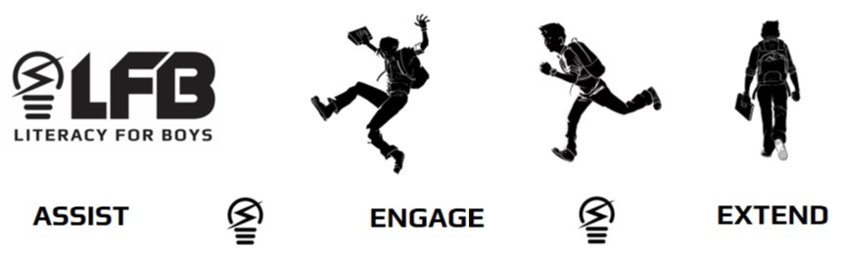
Book Haters (11+ years)

This group is tough to crack: they declare that they hate books. He might like only sports/fishing/gaming mags and thinks that “watching the movie is the same as reading the book”. Here’s some titles that could turn the tide.
(NOTE: NF denotes Non Fiction)
Card, Orson Scott. Ender’s Game (This is a classic science fiction story, given to all non-lovers of science fiction. It features young Ender Wiggins, whose ability at Battle School against the alien Buggers is called into action.
Gibbs, Chris. Build Your Own Sports Car: On a Budget NF (Using regular tools, low-cost parts and a builder’s basic skills, this book provides instructions on how to build an open-top, 2-seater sports car.)
Horowitz, Anthony. Stormbreaker (This is the first in this excellent series. Alex Rider is shocked to learn that his Uncle Ian is not a bank vice president, instead he is a spy for the British Government, a role that Alex is asked to take on.)
Hudson, Noel. The Band Name Book NF (Thousands of bands from more than 30 countries, divided into categories, are found in this text that explains how and where a band got its name. Great book for browsing.)
Miller, Frank. 300 (This recount of the Battle of Thermopylae, in graphic novel format, tells on King Leonidas and his 30 Spartan warriors as they faced the enormous Persian army.)
Myers, Walter, Dean. Monster (Facing murder charges in the killing of a store worker, teen Steve is in jail. He describes the experience in filmmaking terms and diary entries. The reader is left asking: is he innocent or guilty?)
Myers, Walter, Dean. Sunrise over Fallujah (After the 9/11 attacks, Robin Perry enlists in the army, trains and is sent to Iraq where the ambushes, casualties and use of explosives are almost too much for him.
Packard, Mary and the Discovery Channel. Mythbusters: Don’t Try This at Home NF (This book contains humour, witty props and “at home” experiments. There are 15 excerpts from the Mythbusters tv show which challenges those urban legends: Do you stay drier walking or running in the rain? Will stepping in quicksand suck you to your death?
Paulsen, Gary. My Life in Dog Years (Gary has owned dozens of unforgettable dogs. Each chapter tells of each dog, including Snowball (his first dog), Dirk, the grim protector, the Great Dane Caesar who hid from trick-or-treaters and his true friend Josh, a border collie.
Piven, Joshua and Borgenicht, David. The Complete Worst-Case Scenario Survival Handbook (Almost guaranteed to impress every book hater. Informs readers on how to avoid blind dates, mountain lions, avalanches, runaway golf carts, in addition to stopping speeding bullets.)
Rahimzadeh, Auri and Wozniak, Steve. Geek my Ride: Build the Ultimate Tech Rod NF (A do-it-yourself guide showing readers how to instal gadgets like a game console, in-car networking, LED displays, wireless headphones and video surveillance to totally tech out a car.)
Shigeno, Shuichi. Initial D series (In this fast and exciting manga series, teams of street racers take on one another in this illegal Japanese sport of drift-racing style in the Japanese mountains.)
Smedman, Lisa. From Boneshakers to Choppers: The Rip-Roaring History of Motorcycles NF (From their 1880 invention until today, this well-illustrated book covers motorbikes in the military, stunt riders, gang members, dirt bikers and the average person.)
Weaver, Will. Saturday Night Dirt (An evening storm cancels the track races, so the better drivers turn up at an old dirt track at Headwaters Speedway. The usual drivers aren’t used to the next-level competition.)
Woodford, Chris and Woodcock, Jon. Cool Stuff 2.0 and How it Works (To quote one boy, “Fun to read because it’s full of information, photos and futuristic stuff.” It tackles topics such as earthquake proofing, virtual reality and space planes.)

